Supplemental material to Retribution as hierarchy regulation: Hierarchy preferences moderate the effect of offender socioeconomic status on support for retribution

Exploratory Factor Analysis

This supplement is associated with the paper “Retribution as hierarchy regulation: Hierarchy preferences moderate the effect of offender socioeconomic status on support for retribution”. It examines the simple effects of Offender Status at high and low Social Dominance Orientation (SDO) on Retributive Justice Orientation. The main manuscript reports simple effects at one standard deviation above and below the mean of SDO. However, because each sample was relatively low in SDO, one standard deviation above the mean represented people who were not actually scoring above the midpoint on the scale.[1] To better test our hypotheses and represent truly low and truly high SDO, we conducted additional analyses defining high and low SDO in terms of high and low scores on the scale (1 and 7).

Study 1

At a score of 1 on SDO, greater Offender Status produced greater RJO, *b* = 0.10 (95% CI = 0.02, 0.17), β = .15, *SE* = .04, *p* = .01 (see Figure 1). At a score of 7 on SDO, greater Offender Status produced lower RJO, *b* = -0.29 (95% CI = -.58, 0.01), β = -.47, *SE* = .35, *p* = .046. In other words, low-SDO participants scored higher on RJO for high-status offenders, and high-SDO participants scored high on RJO for low-status offenders.

Study 2

At a score of 1 on SDO, greater Offender Status produced greater RJO, *b* = 0.69 (95% CI = 0.49, 0.89), β = .34, *SE* = .10, *p* < .001 (see Figure 2). At a score of 7 on SDO, greater Offender Status produced lower RJO, *b* = -0.77 (95% CI = -1.44, -0.09), β = -.37, *SE* = .35, *p* = .03.

In other words, as in Study 1, low-SDO participants scored higher on RJO for high-status offenders, and high-SDO participants scored high on RJO for low-status offenders.

Study 3

At a score of 1 on SDO, greater Offender Status produced greater RJO, *b* = 0.75 (95% CI = 0.56, 0.94), β = .36, *SE* = .10, *p* < .001 (see Figure 3). At a score of 7 on SDO, greater Offender Status produced lower RJO, *b* = -0.64 (95% CI = -1.21, -0.07), β = -.31, *SE* = .29, *p* = .03.

In both previous studies, low-SDO participants (scoring 1 on SDO) reported greater RJO for high-status offenders, and high-SDO participants (scoring 7 on SDO) reported greater RJO for low-status offenders. That same pattern of results was replicated in the current study.

Meta-analysis

Because all three studies were designed to address the same hypotheses, but produced slightly different effect size estimates, we conducted a meta-analysis to summarize the findings with regard to high- and low-status offenders (Cooper, 2010; Card, 2011). From all three studies, partial correlations between hierarchy preferences and retributive justice orientation were combined. This meta-analysis revealed, firstly, a significant interaction effect (pooled partial correlation *r*p = -.12, 95% CI = -.16, -.08) that was homogeneous across studies (Heterogeneity *χ*2 = .12, *p* = .94). A meta-analysis of the simple effects of offender status at high Social Dominance Orientation (SDO) showed a negative relationship such that lower offender status predicted greater Retributive Justice Orientation (RJO), *r*p = -.07, 95% CI = -.03, -.12, an effect that was also homogeneous across studies (Heterogeneity *χ*2 = .05, *p* = .97). Another meta-analysis, for low-SDO participants, showed that greater offender status predicted greater RJO, *r*p = .20, 95% CI = .13, .27, an effect that was also homogeneous across studies (Heterogeneity *χ*2 = 5.71, *p* = .06). These meta-analytic findings echo those of all three individual studies, in which hierarchy preferences interact with offender status in predicting retributive justice orientation.

References

Card, N. A. (2011). *Applied meta-analysis for social science research*. Guilford Press.

Cooper, H. (2010). Step 5: Analyzing and integrating the outcomes of studies. In *Research*

*synthesis and meta-analysis*: 145-196). Thousand Oaks, CA: Sage.

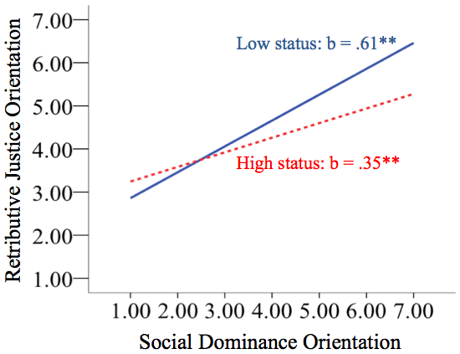

*Figure 1.* Results from Study 1: Relationship between Social Dominance Orientation and Retributive Justice Orientation in regard to low- or high-status target offenders. Unstandardized coefficients are shown. (\**p* < .05, \*\**p* < .001)*.*

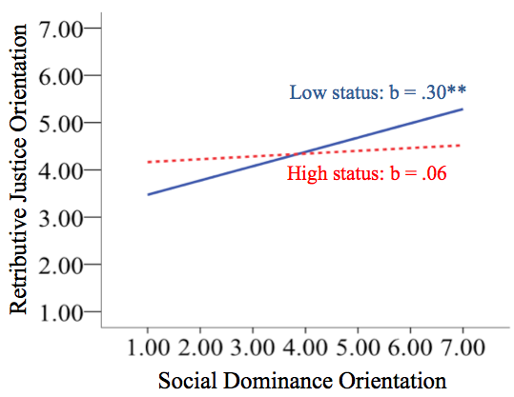

*Figure 2.* Results from Study 2: Relationship between Social Dominance Orientation and Retributive Justice Orientation in regard to a low- or high-status target offender. Unstandardized coefficients are shown. (\**p* < .05, \*\**p* < .001)*.*

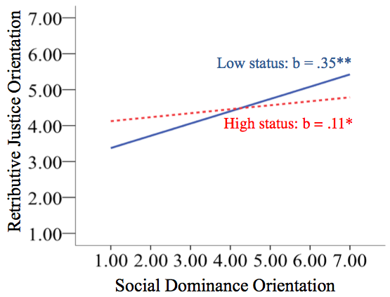

*Figure 3.* Results from Study 3: Relationship between Social Dominance Orientation on Retributive Justice Orientation in regard to a low- or high-status target offender. Unstandardized coefficients are shown. (\**p* < .05, \*\**p* < .001)*.*

1. Although there were relatively few cases scoring high on Social Dominance Orientation, examination of studentized deleted residuals showed that no cases exerted undue impact on the model.